**SMARTIO Quick Manual**

Hold your SMARTIO facing the keypad with the speaker on the left and **Mode** button on the right of the device. **Power** button is on the bottom, and **Volume** buttons are on the top.

**1.The Location of Function Keys**

* 1. On the top: Volume Down (-) and Volume Up (+) buttons
  2. On the front side: Speaker, keypad, Mode button, LED
  3. On the right side: Mike, USB-C, Earphone jack
  4. On the bottom: Power Button
  5. Functions:

**Power Button** : Press and hold to turn the device on and off.

**Volume Button** : Raise or lower the volume.

**Mode Button** : Select Navigation Mode or Input Mode.

**USB-C** : charge battery or update firmware.

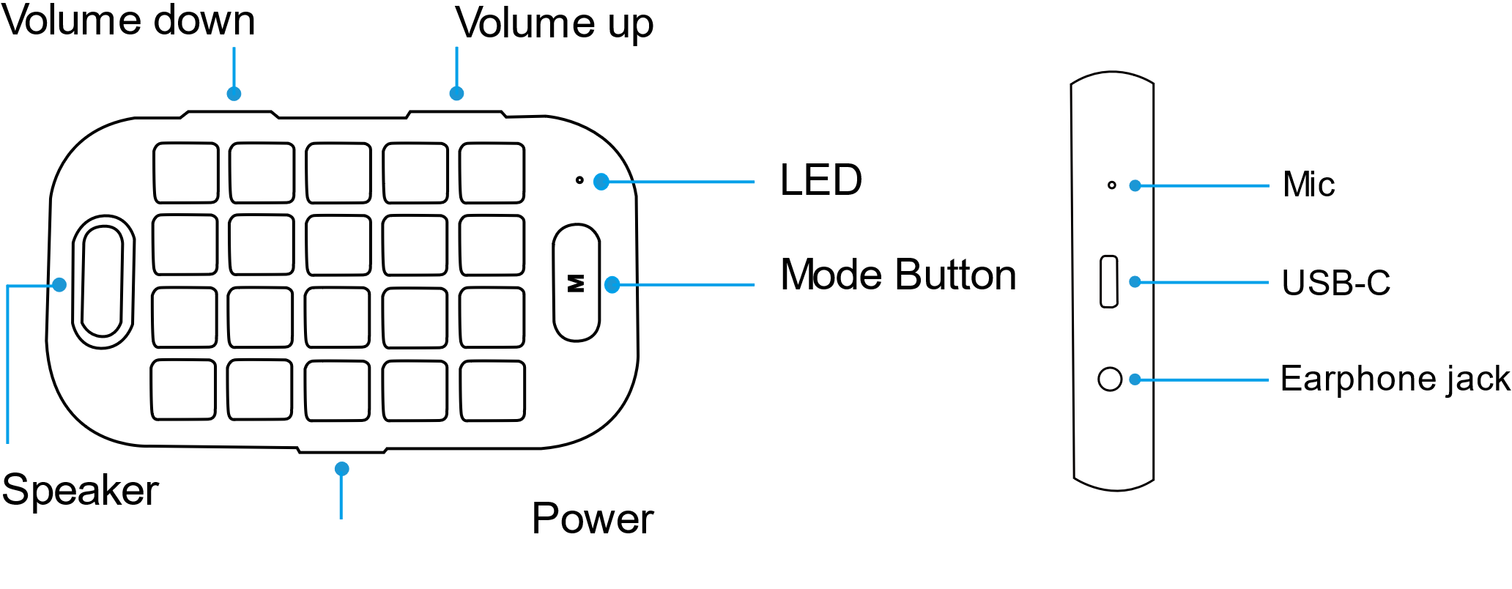

**2. Power On/Off, Keypad Lock, Silent Mode**

* 1. **Power On** : Press and hold **Power button**. You will hear “Power is on,” and the device will be turned on.
  2. **Power Off** : Press and hold **Power button**. You will hear “Power is off,” and the device will be turned off.
  3. **Lock Your Keypad** : Press N5 key for more than 5 seconds. You will hear, “The keypad is locked,” and the keypad will be locked.
  4. **Unlock Your Keypad** : Press N5 key for more than 5 seconds. You will hear, “The keypad is unlocked,” and the keypad will be unlocked.
  5. **Silent Mode** : If you press Volume Down (-) and Volume Up (+) buttons simultaneously, you will hear “The audio is muted,” and the device will be in silent mode.
  6. **Release Silent Mode** : Press Volume Down (-) and Volume Up (+) buttons simultaneously to release your device from Silent Mode as you will hear “The audio is unmuted.”

1. **Bluetooth Pairing** 
   1. **Initial Pairing:** Turn on your SMARTIO. After activating Bluetooth on your smartphone, search and connect SMARTIO. When the pairing is completed, you will hear “Bluetooth is connected.”
   2. **Reconnecting:** If you lost Bluetooth connection, try to reconnect by pressing **Mode** button.
2. **OS Settings** 
   1. **OS settings:** Set up the OS of your SMARTIO.
      1. IOS : **Volume Down** button + **L1** key + **Mode** button. You will hear “IOS Mode.”
      2. Android : **Volume Up** button + **L1** key+ **Mode** button. You will hear “Android Mode.”

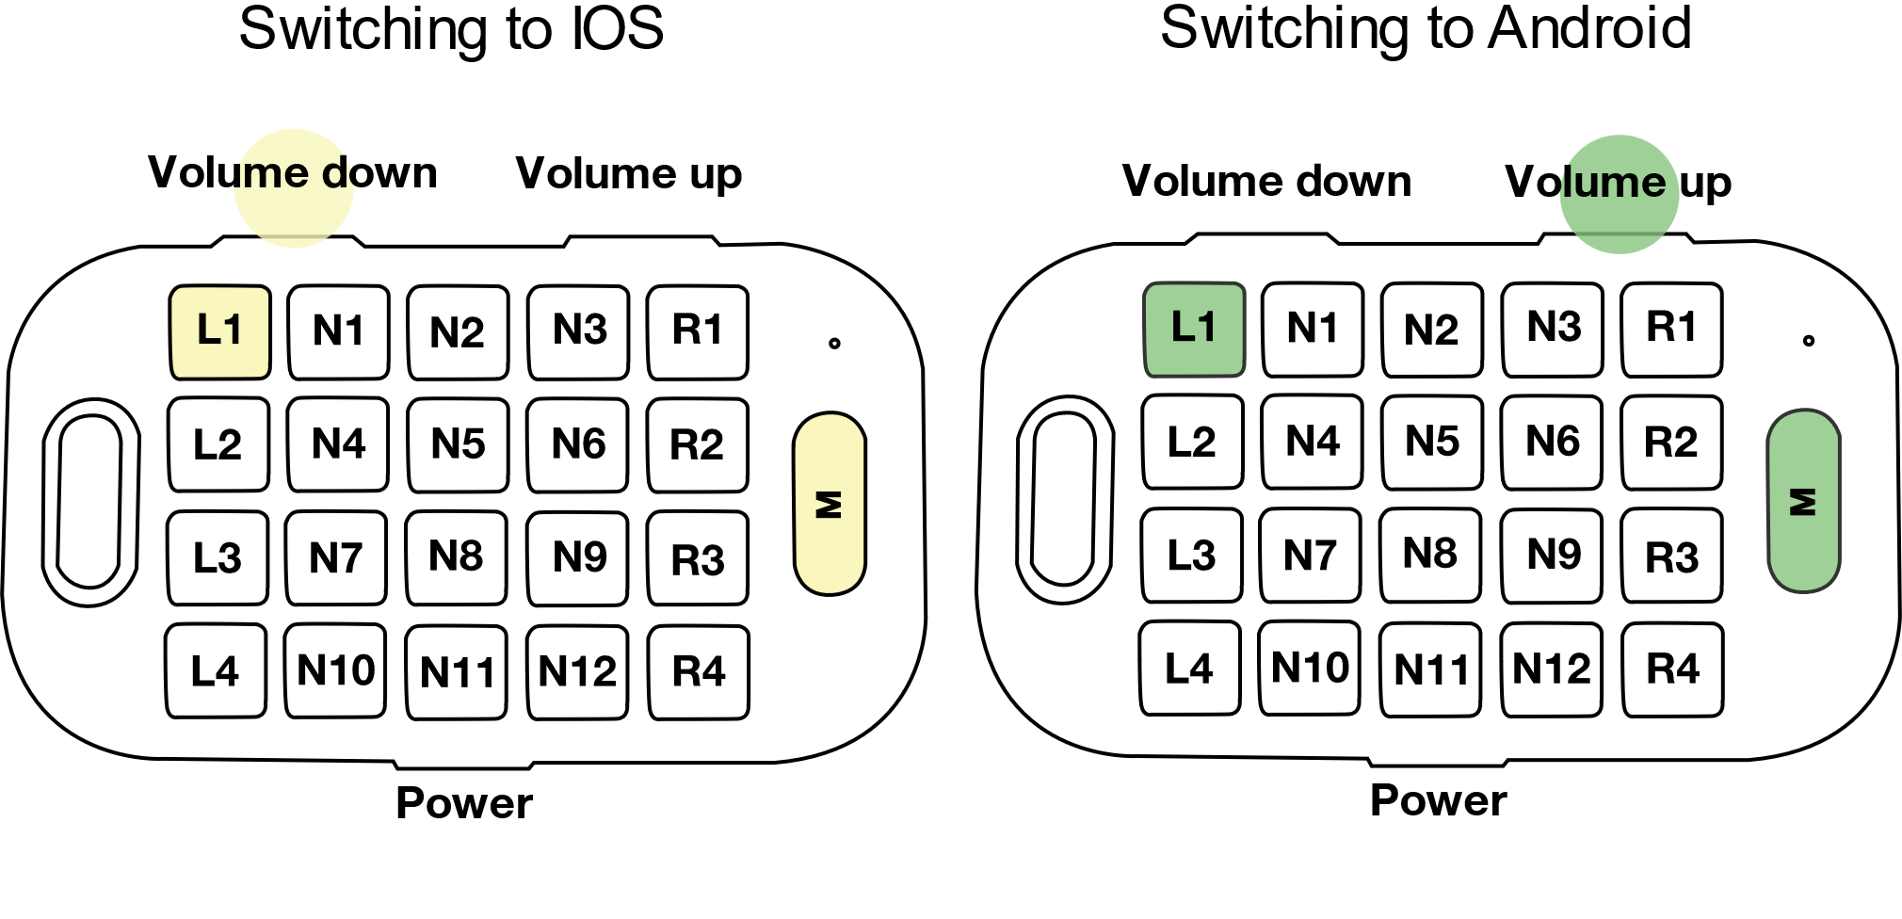

**5. Battery**

* 1. **Checking the Charging Status:** **Mode** button + **Power** button
     1. You will hear “25% of the battery is left” when there is a 25% of battery left.
     2. You will hear “50% of the battery is left” when there is a 50% of battery left.
     3. You will hear “More than 75% of the battery is left” when there is a 75% of battery left.
  2. **How to Charge Your Battery:** Use a USB-C type charging cable. When your battery is fully charged, you will hear “Charging has completed” with green light on.
  3. **Sleep Mode** : If there is no activity on your SMARTIO for 5 minutes, it is automatically switched to Sleep Mode. Press any button to start using the device, then the device will try connecting Bluetooth.

*When not in use, please turn off your SMARTIO to prevent a dead battery.

**6. Mode Settings**

* 1. **Mode Settings** : Press **Mode** button to toggle between Navigation Mode and Input Mode.
  2. **Braille input Mode**: If you press R4 key for more than 3 seconds in Navigation Mode, you will hear “braille mode” and move to Braille Mode. Hold your SMARTIO facing the back of your keypad.
  3. **Browser Mode** : If you press N12 key for more than 3 seconds, you will hear “browser mode” and move to Browser Mode.

**7. Changing input language**

* 1. **Changing Language:** Switch languages in Input Mode. Press L2 key to toggle between Arabic and English.
  2. **Language Synchronization:** If the letters you typed in SMARTIO are not inputted in your smartphone properly: Press **L2** key+ **Mode** button for more than 3 seconds to synchronize the language.

**8. Input printed text**

8.1 **Capital letter:** Type in letters while pressing **L4** key (Shift).

8.2 **Number and Symbol:** Press **L3** key to input numbers, and press **L3** key again for additional symbols. To go back to Text Input Mode, press **L1** key.

8.2.1 Backspace key : R1

8.2.2 Space key : R2

8.2.3 Enter key : R3

**9. Input Braille**

9.1 Basic input : N3,6,9,1,4,7 are Dot 1,2,3,4,5,6.

9.2 symbol input : If you want to input symbol, Press L4 key and type the symbol. And than Press L4 key again, you will return to Braille input mode.

