Getting Started
  - About SMARTIO
- Before using, turn on your smartphone screen reader program and check the pairing between SMARTIO and smart phone.
    - Hardware
      - On the front side of SMARTIO is a keypad consisting of 20 keys in 4 rows and 5 columns.
      - On the left of the keypad is a speaker, and on the right, Mode button.
      - On top, from the left, there are Volume buttons, - (down) button and + (up) button.
      - There is a hole to insert strip on the left edge of the keyboard.
      - From top right side of the keyboard are a mic jack, a USB-C port to charge battery and transfer data, and an earphone jack.
      - Power button is on the bottom of the keyboard.
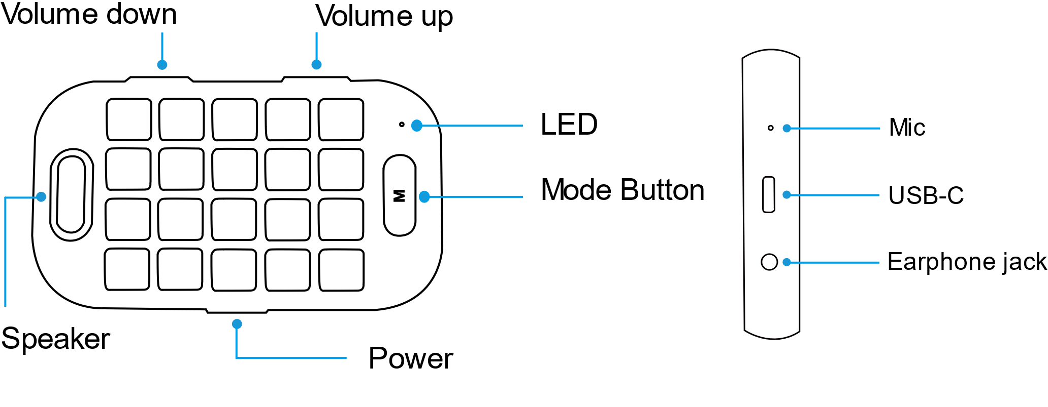

    - Control and Input Mode
    - SMARTIO is composed of 3 modes for compatibility with screen readers such as VoiceOver, TalkBack, and Voice Assistant, control over your mobile phone, and input function support.
    - Navigation Mode: You can find an application, control the device, and use other user convenience functions.
    - Input Mode: You can input letters, numbers, and symbols.
    - Browser Mode: You can use a representative browser of each OS using a separate command.
    - If you want to raise or lower volume of SMARTIO guide voice, press Mode button and Volume buttons together.
*To lower the volume: Volume Down (-) button + Mode button
*To raise the volume: Volume Up (+) button + Mode button

    - Keypad Name
      - The keys are given names with a number to help you understand the system easily, and the names will be used to explain how to use SMARTIO.
      - The first column is named L1, L2, L3, L4 from top to bottom.
      - The fifth column is named R1, R2, R3, R4 from top to bottom.
      - In the second, third, and fourth columns, there are 12 keys like a T9 keyboard (phone keypad). From the first row on the left to the right, they are named N1 to N12.
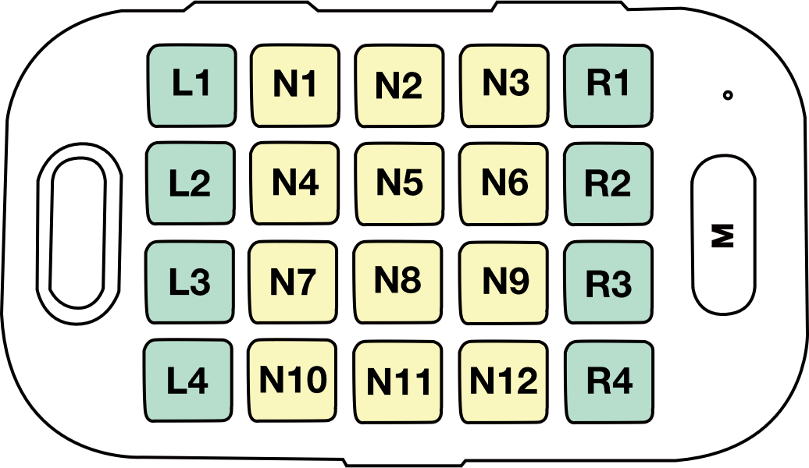

  - Basic Functions
    - Notification for the State of the Device
      - Charging Battery
When the battery is being charged : Red light is on.
When the battery is fully charged : Green light is on.
b. How to check the battery life: Mode button + Power button
25% or more : You will hear “25% of the battery is left.”
50% or more : You will hear “50% of the battery is left.”
75% or more You will hear “More than 75% of the battery is left .”

c. Bluetooth Pairing
While pairing : Blue light blinks.
When pairing is completed : Blue light is on.
d. Calls
When receiving a call : Green light blinks.
On the line : Green light is on.

- Change Voice Guidance Language
Arabic Voice Guidance : L4 key + Volume down (-) button + Mode button
English Voice Guidance : L4 key + Volume up (+) button + Mode button
2. How to Check the Current Setting
      - Check the current OS: Mode button + L1 key
        - IOS Mode : You will hear “IOS Mode.”
        - Android Mode : You will hear “Android Mode.”
      - Check the current SMARTIO language: Mode button + L2 key
        - Basic Mode : You will hear “Arabic Mode.”
        - Foreign Language Mode : You will hear “English Mode.”
    - Switching Mode
      - Press Mode button to switch between Navigation Mode and Input Mode.
Go to Braille Mode: Press R4 key for more than 3 seconds in Navigation Mode to switch to Braille Mode. And then You will hear “Braille Mode.” To switch back to Navigation Mode, press Mode button again.
      - Press N12 key for 3 seconds to move to Browser Mode. The command only works in Navigation Mode.

    - Charging Battery
      - Use a USB-C type cable to charge SMARTIO.
      - It takes 3 hours for SMARTIO to be fully charged, and the battery life will vary depending on the amount of usage.
    - Bluetooth Pairing
- Initial Connection: Turn on SMARTIO. After activating Bluetooth on your smartphone, search and connect SMARTIO. When the pairing is completed, you will hear “Bluetooth is connected.”
- Reconnecting: If you lost Bluetooth connection, try to reconnect by pressing Mode button.
    - Audio Output Control
      - Setting Silent Mode: If you press Volume Down (-) button and Volume Up (+) button simultaneously, with voice saying “The Audio is muted,” now you have set Silent Mode.
      - Releasing Silent Mode: If you press Volume Down key and Volume Up key simultaneously in Silent Mode, you will hear “The Audio is unmuted.”
    - Switching OS: SMARTIO supports IOS and Android.
      - Switching to IOS Mode: Mode button + L1 key+ Volume Down (-) button
      - Switching to Android Mode: Mode button + L1 key+ Volume Up (+) button
    - Locking the Keypad
      - To lock your keypad, press N5 key for more than 5 seconds. You will hear “the keypad is locked.”
      - To unlock your keypad, press N5 key for more than 5 seconds. You will hear “the keypad is unlocked.”
    - Firmware Update
a. Before firmware update
- Prepare a USB-C type flash drive. (We recommend using an empty flash drive, and do not change the name of firmware update file.)
- Download firmware from “www.md-smartio.com” and store it in your flash drive.
- We recommend updating firmware when the battery level is 50% or more.
b. Firmware Update:
- Turn on SMARTIO and connect the flash drive.
- Press L1 + L4 + R1 + R4 for more than 3 seconds. As green light blinks, you will hear “Firmware update is started,” and the update begins.
- Please do not remove the flash drive or turn off SMARTIO.
- If the update is completed, you will hear “update has been completed” with green light on, and the device will turn off. If the update was not completed normally, you will hear “error”.
- If the update was not completed normally, turn off and on the device and proceed update again.
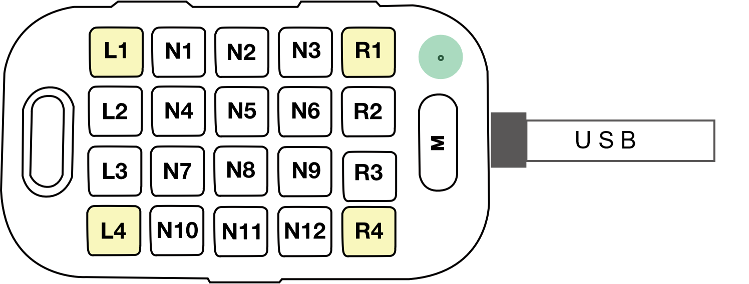

    - How to Reset system setting
      - Press Power button + Mode button + N5 key simultaneously for about 5 seconds.
      - If you turn it on, the device is reset.

  - Functions for User Convenience
      - Phone Call Function: This function will be ready soon.

      - Voice Command (Siri, Google assistant): is available in Navigation Mode.
        - To input a voice command, press and hold N11 key for more than 3 seconds to activate Siri or Google assistant.
        - To finish the voice command input, press L1 key.

